**Walmart Supermarket Insights Visualizing Data with Tableau**

**Problem Statement:**

ABC Company aims to leverage the Walmart Supermarket dataset to optimize sales and operational efficiency. The company seeks to develop accurate sales forecasts, evaluate store performance, optimize holiday sales strategies, understand regional variations, assess markdown effectiveness, and improve operational efficiency. By addressing these challenges, ABC Company aims to gain a competitive edge, enhance customer satisfaction, and achieve sustainable growth. The goal is to drive competitive advantage, improve customer satisfaction, and foster long-term growth.

**Prerequisites:**

* Basic understanding of Data Analytics

[What Is Data Analytics? - An Introduction (Full Guide)](https://youtu.be/yZvFH7B6gKI?si=jD37tQzKJH1vl56A)

* Awareness of the lifecycle of a Data Analytics Project

[A Beginners Guide To The Data Analysis Process](https://youtu.be/lgCNTuLBMK4?si=a_J79oNSQIGNuNlH)

* Understand Tableau Interface- [Link](https://www.youtube.com/watch?v=oIw8xJ1Fy3w)
* Download Tableau Desktop-[Link](https://www.tableau.com/products/desktop/download)

**Objective:**

An objective is a specific, measurable, and time-bound goal or target that an individual or organization aims to achieve. Objectives are typically set to guide actions and decision-making towards desired outcomes. They are often a part of broader goals and help to clarify what needs to be accomplished within a certain timeframe. Objectives should be realistic, achievable, and relevant to the overall mission or purpose, providing a clear direction for efforts and resources.

**Task:**

* Visualize the distribution of stores based on the count of weekly sales to identify variations in sales performance across different store locations.
* Gain insights into the concentration of high-performing and low-performing stores, enabling strategic decision-making regarding resource allocation and sales optimization strategies

**Dataset**: [Link](https://www.kaggle.com/datasets/saurabhbadole/walmart-super-market-dataset)

**Solution Development Procedure:**

* In Tableau, the "Connect" option refers to the initial step in the data visualization process where users connect to various data sources to import data into Tableau for analysis and visualization.

* When you select the "Connect" option in Tableau, you are presented with a variety of data connection options.

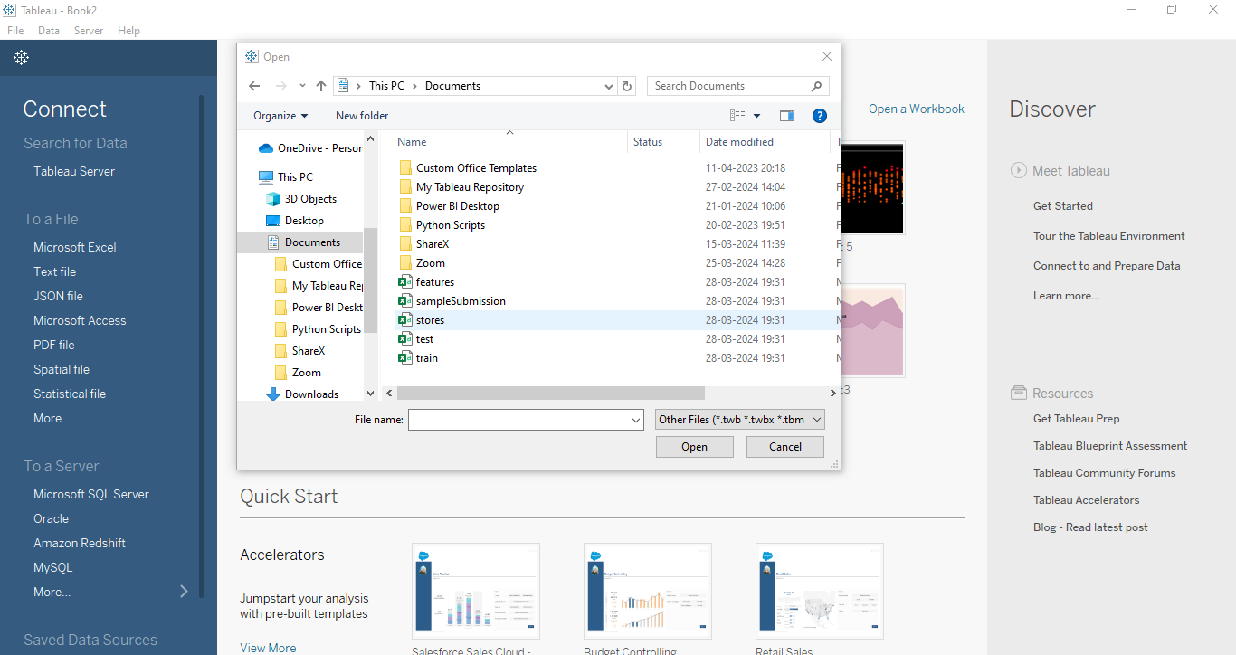

* Load the dataset into the Tableau.

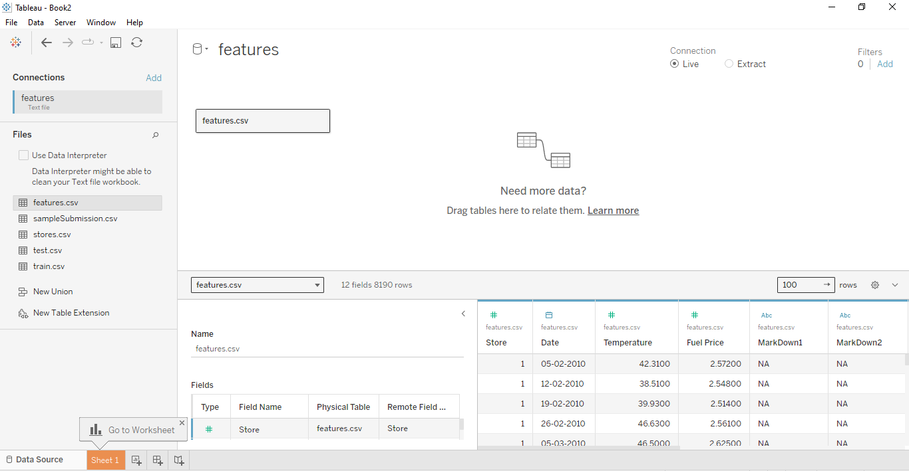

* Create the relationships between the tables.

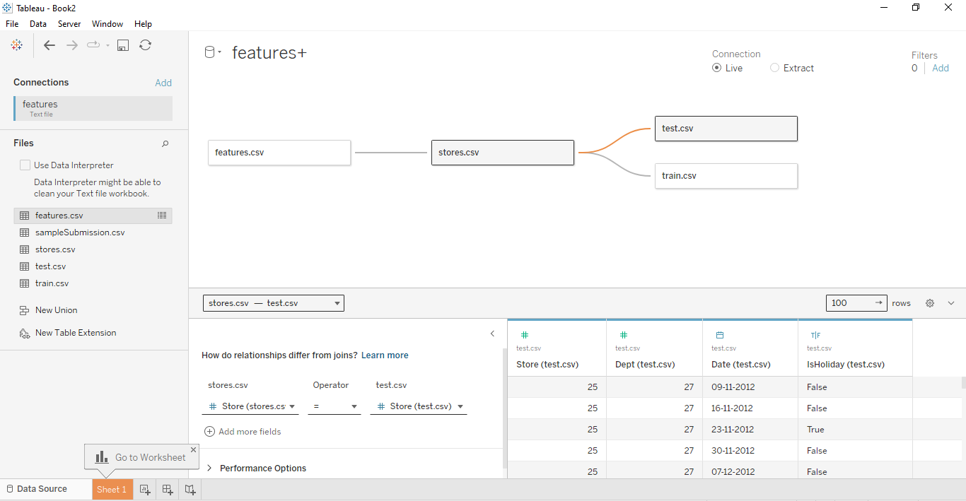

* Switch to Worksheet and select store and choose Bar Graph visual.

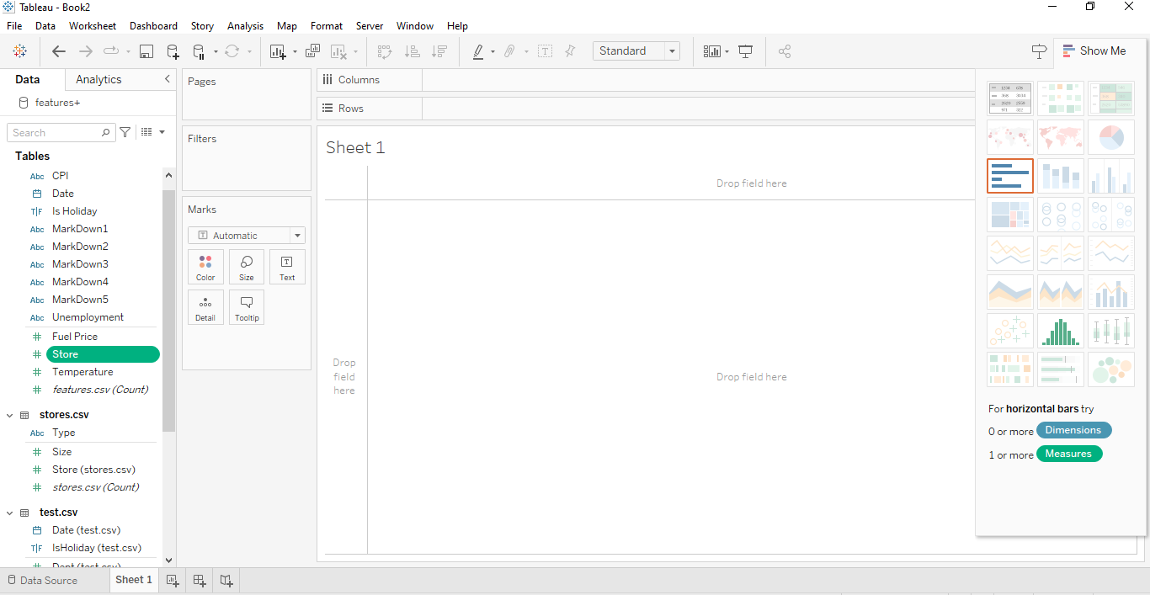

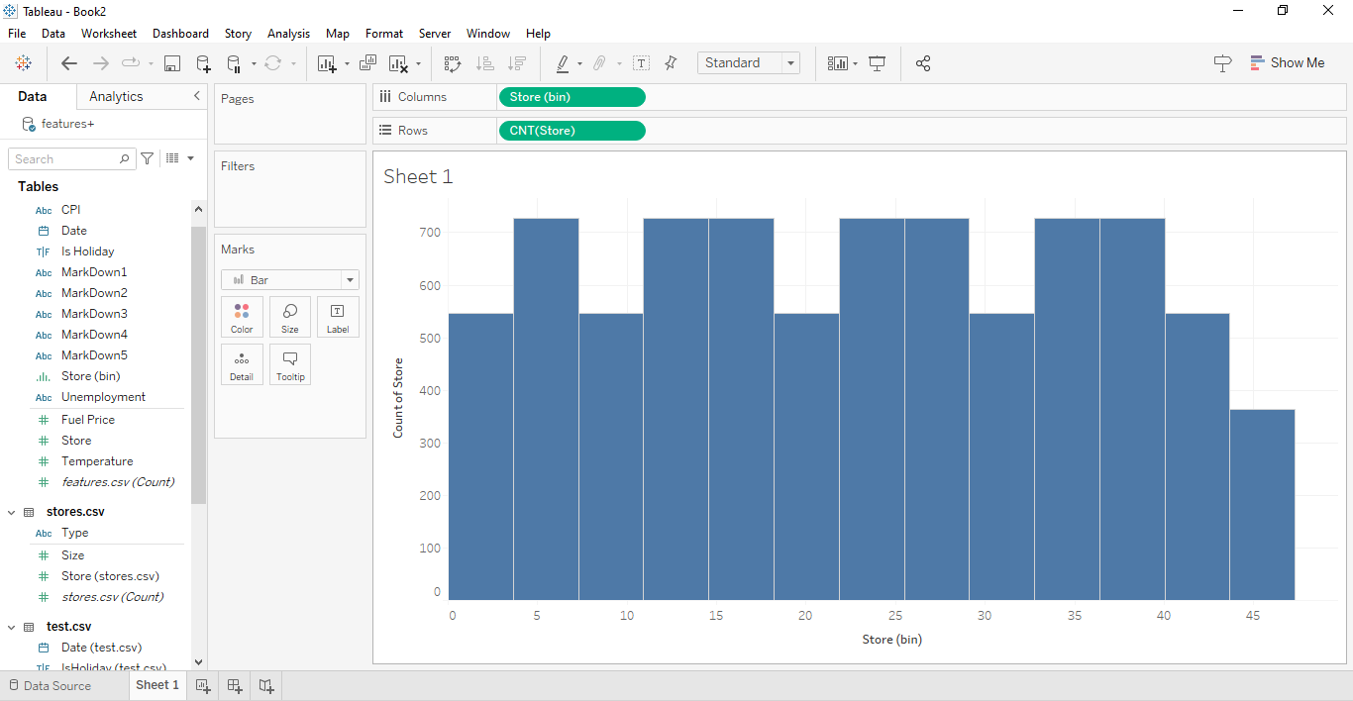

* Drag Count of Store into the colour and Count of Weekly Sales into the label in the Marks Card.

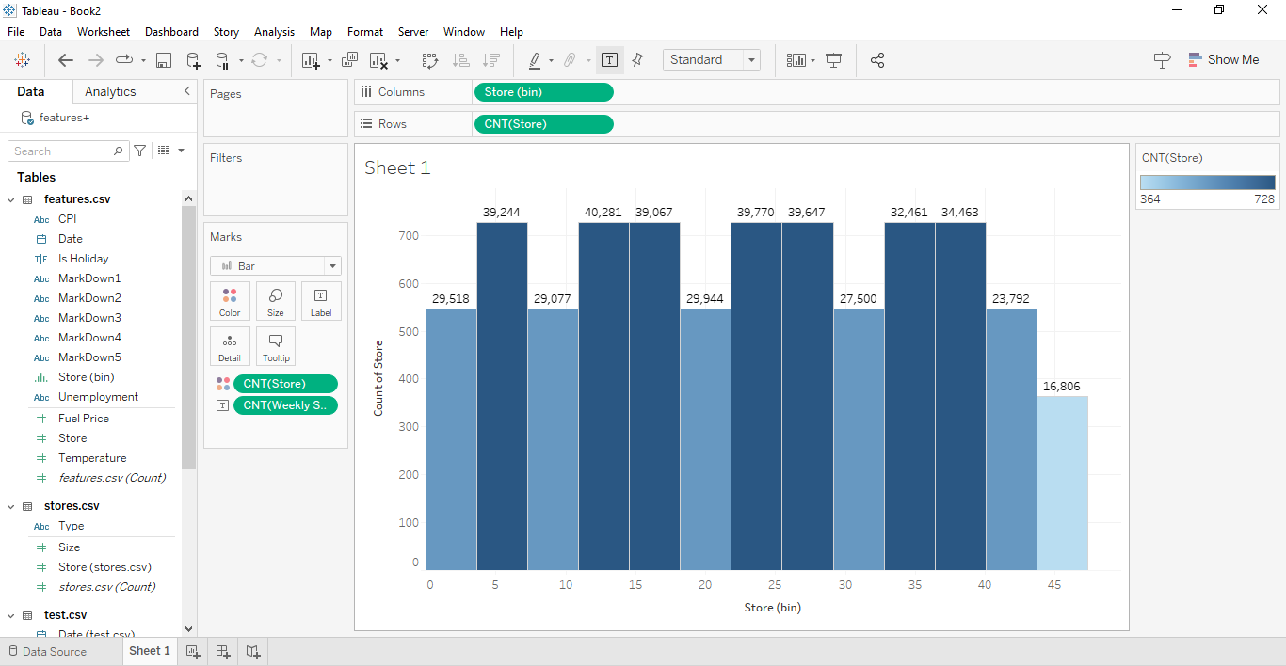

* Through the Quick Table Calculations, Convert Count of Weekly Sales to Percent of Total.

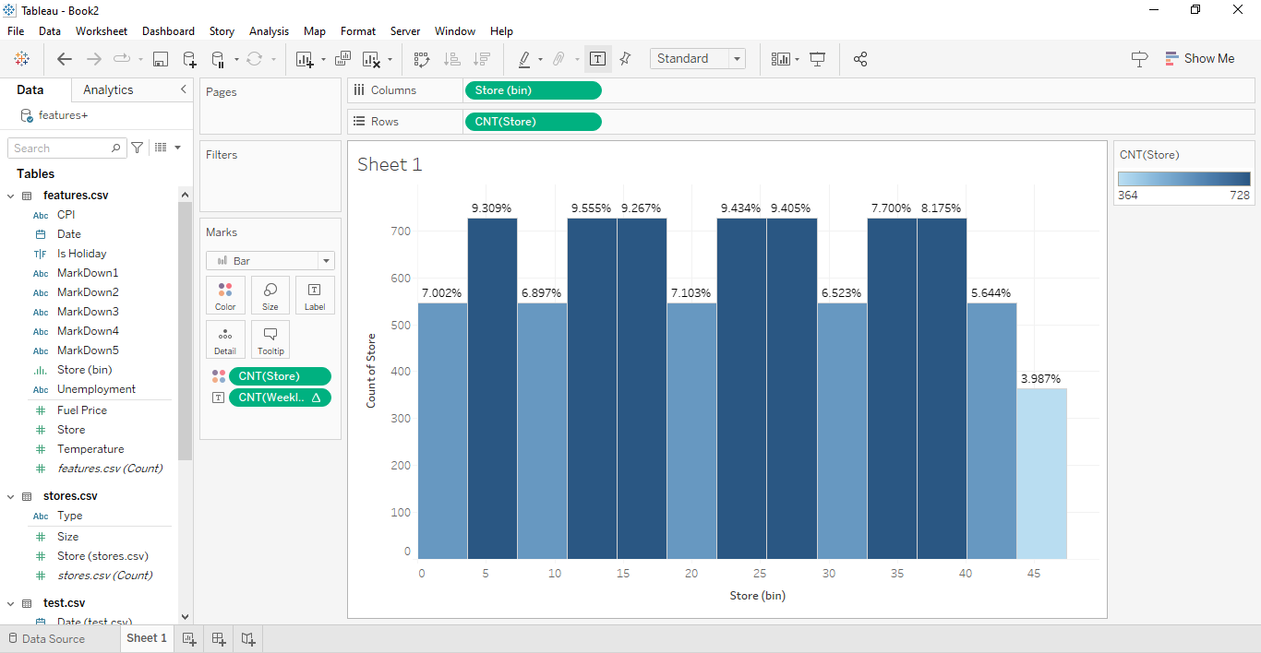

* Format Percent of Total by decreasing its decimal values.

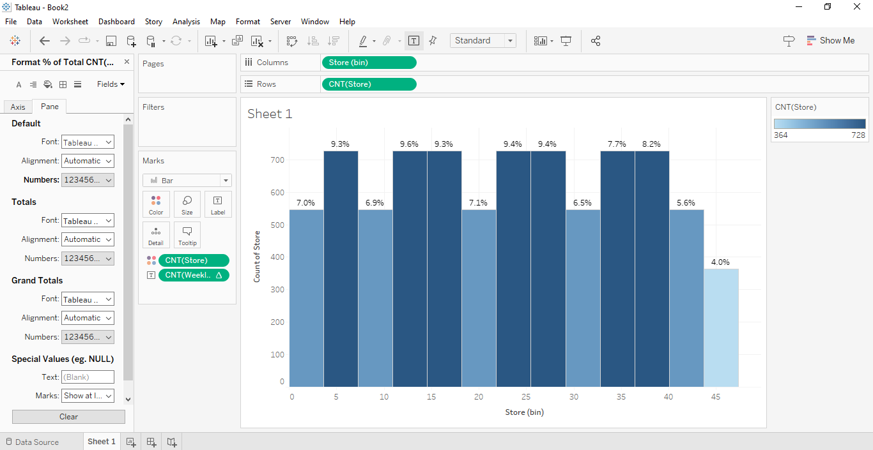

* Customize Title and Format Background, Borders and Shading.

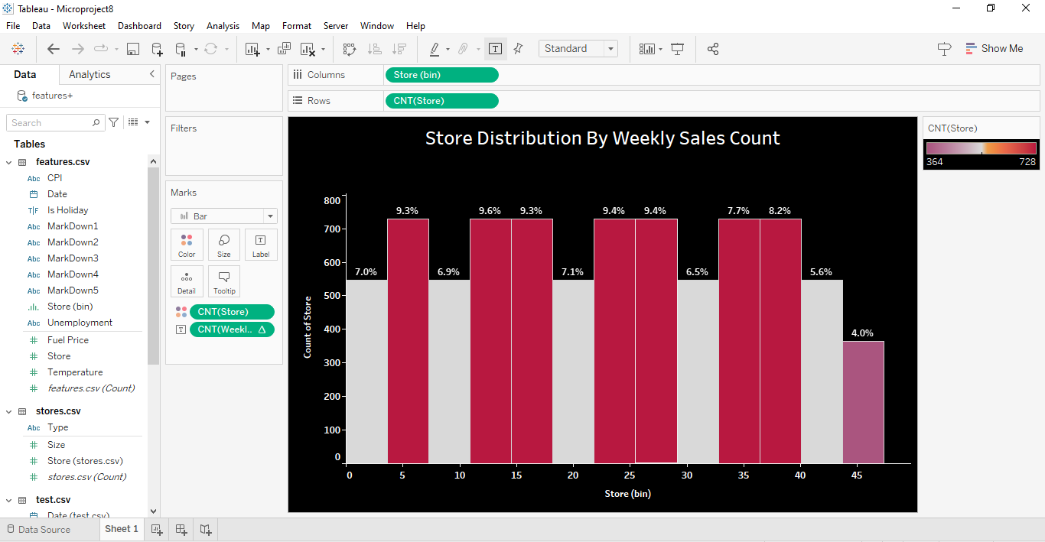

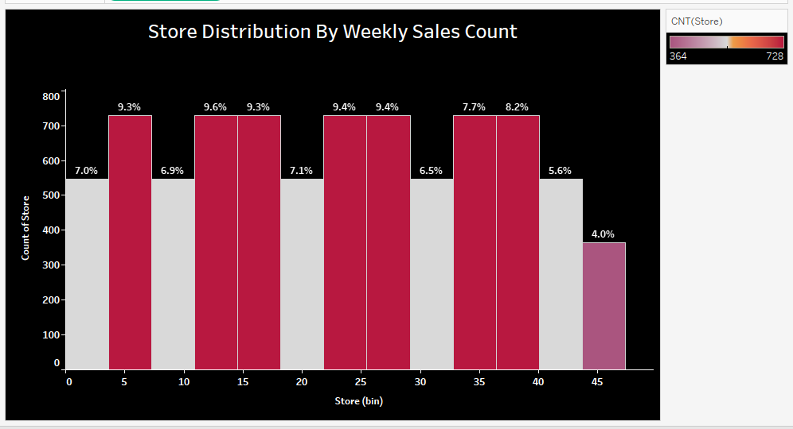

**Insights:**

Insights refer to valuable and meaningful understandings or perceptions gained from analyzing data, information, or experiences. They provide deeper understanding, clarity, or revelation regarding a particular subject or situation.

* Identification of high-performing stores with consistently strong weekly sales and low-performing stores with lower sales counts, allowing for targeted strategies to optimize sales performance and allocate resources effectively.
* Identification of key attributes or factors that differentiate high-performing stores from low-performing ones, facilitating the development of targeted improvement initiatives.

**Conclusions :**

Conclusions are logical deductions or decisions drawn from observations, evidence, or analysis. Conclusions are often based on the findings or results of a study, experiment, or evaluation, and they aim to summarize key insights or outcomes. Effective conclusions should be supported by evidence, logical reasoning, and critical thinking, leading to well-informed decisions or actions.

* The visualization of sales distribution by weekly sales count highlights distinct performance trends among stores, with some consistently achieving higher sales counts while others exhibit lower counts, indicating areas for potential improvement.
* Analysis highlights varying sales patterns across different stores, with certain locations showing higher concentrations of stores with elevated weekly sales counts. This insight underscores the importance of tailored strategies to capitalize on favourable market conditions and address sales challenges in less-performing stores.
* These findings serve as a valuable guide for strategic decision-making, allowing for more informed resource allocation and targeted interventions. By focusing efforts on high-performing stores and implementing tailored strategies to boost sales in underperforming locations, companies can optimize sales performance and drive sustainable growth in the retail sector.